IMPORTANT INFORMATION BEFORE TURNING IN

YOUR TRIBAL APPLICATION
When applying for tribal positions, be sure that you include the following information in your application materials:
Tribal Application (MAKE SURE YOU SIGN; OTHERWISE YOU WILL BE DISQUALIFIED).
- Answer the question on Page 6 of the application: Why are you the best candidate for this
position? Failure to complete this question will result in your application being marked
"Incomplete" and you will not be considered for the position for which you are applying.
- Copies of Transcripts, Diplomas, Etc., if claiming education (Failure to include these documents may cause low rating of application.)
- Tribal Enrollment (verification can be picked up at the Blackfeet Tribal Enrollment Department, or submit a copy of Tribal Enrollment Identification Card. Failure to include documentation may cause low rating of the application.)
- Veteran Preference (Please submit a copy of DD Form 214 if claiming Veteran Preference.) If a veteran has a service-connected disability, you must provide documentation and percentage.
- Must submit a copy of Valid Driver's License.

After applicants are rated, the top qualified applicants will be sent notifications of interview by mail.

Step 1.  SUBMIT APPLICATION | The Personnel Department is not responsible for submitting applications from previously advertised positions towards currently advertised positions. Application should be filled out completely. Original signature required on part 9, and submitted by the closing date.  It is beneficial to attach a resume that lists all work experience.  It is the responsibility of the applicant to supply all training certificates, diplomas, transcripts, verification of enrollment, DD Form 214 if claiming Veteran Preference and driver's license.  Applicant must answer the question on Page 6 of the application.  For your own protection and security, make a copy of everything being submitted.
Step 2.  SELECTION COMMITTEE ESTABLISHED | Director of the Program/ Department of the advertised position(s) establishes an Application Rating Committee of no less than three (3) individuals to rate the applications.  Personnel Department's role is to ensure all applicants are given fair opportunity to be considered for the position(s). Staffing Specialist assists the Application Rating Committee in rating the applications.
Step 3.  APPLICATION RATING | The Personnel Department Staffing Specialist schedules, and assists the Application Rating Committee in rating the applications.  Applications are rated primarily on experience, education, and on specialized training.  Preference is given to enrolled Tribal members, and Veterans.
Step 4.  INTERVIEW RATING | The Personnel Staffing Specialist contacts via letter, all top qualified applicants to be interviewed, with scheduled interview date, and time.  Staffing Specialist also assists the Interview Selection Committee in interviewing the top qualified applicants.
Step 5.  SELECTION OF TOP CANDIDATES | Scores of applications and interviews are combined to identify the top candidate for the position(s). Personnel Director certifies top candidate. Official Letter of Hire is sent out to selected applicant.
Application Process Information Sheet

APPLICATION FOR EMPLOYMENT
BLACKFEET TRIBE
Note: A separate application is required for each position for which you are applying
PART 1 |  |  |  |  | GENERAL INFORMATION
NAME (LAST, FIRST, MIDDLE, MAIDEN) |  |  |  |  |  |  |  | ADDRESS (BOX, CITY, STATE, ZIP)
HOME PHONE: |  |  |  |  |  |  |  | EMAIL ADDRESS:
CELL PHONE: |  |  |  |  |  |  |  | WORK PHONE.
POSITION FOR WHICH YOU ARE APPLYING:
HAVE YOU EVER WORKED FOR THE BLACKFEET TRIBE? _____YES _____NO
(IF YES, IDENTIFY PROGRAM, POSITION, AND DATE OF EMPLOYMENT)

 | PART 2 |  |  |  |  |  | AVAILABILITY
 | WHEN ARE YOU AVAILABLE TO WORK?  MONTH/DAY/YEAR |  |  |  |  |  |  |  | WHAT IS THE LOWEST PAY YOU WILL ACCEPT?  PAY $ PER
 | PART 3 |  |  |  |  |  | EDUCATION
ARE YOU A HIGH SCHOOL GRADUATE OR HAVE YOU COMPLETED YOUR GED
(HIGH SCHOOL EQUIVALENCY)? YES NO
IF NOT, WHAT IS THE HIGHEST GRADE YOU COMPLETED?
HAVE YOU EVER ATTENDED COLLEGE OR GRADUATE SCHOOL? YES NO
F YES, CONTINUE WITH FORM BELOW (ATTACH ALL DOCUMENTATION *SEE NOTE
 |  |  |  |  |  | MM/YY ATTENDED |  |  |  | CREDIT HRS | MAJOR.COURSE |  |  | MM/YY
 |  |  |  |  |  | FROM: TO: |  |  |  | COMPLETED | OF STUDY |  |  | DEGREE

EDUCATION CONTINUED

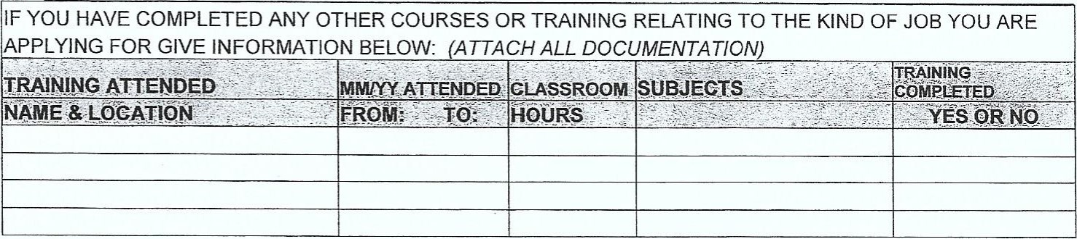
PART 4 |  |  |  | SPECIAL QUALIFICATIONS & SKILLS
TYPING ABILITY: |  |  |  | SHORTHAND OR SPEED WRITING:
SUMMARIZE SPECIAL SKILLS, QUALIFICATIONS, ACCOMPLISHMENTS, AND AWARDS ACQUIRED
FROM EMPLOYMENT OR OTHER EXPERIENCES THAT MAY QUALIFY YOU FOR THIS POSITION:
LIST JOB RELATED LICENSES OR CERTIFICATES THAT YOU HAVE, i.e., REGISTERED NURSE, LAWYER, RADIO OPERATOR, DRIVER, PILOT, etc..
LICENSE OR CERTIFICATE  1 |  |  |  |  | EXPIRATION DATE | ISSUING AGENCY
2
3
PART 5 |  |  | PREFERENCES
Are you a veteran of the US Armed Forces? ________ YES __________ NO
Branch of Service: _________________________________ From: _______________ To: ________________
Honorably discharged? Yes No
Service connected disability? Yes No Percentage
Are you an enrolled member of the Blackfeet Tribe? ________ YES _________ NO
Are you married to an enrolled member of the Blackfeet Tribe? ______YES ______ NO
Are you a descendant of the Blackfeet Tribe? _______ YES ______ NO
Are you an enrolled member of a different Tribe? _____YES ______ NO Tribe Name: _______________________
Enrollment #: _______________________ Spouse Enrollment #: _____________________________
NOTE: CREDIT WILL NOT BE GIVEN FOR HIGHER EDUCATION AND/OR OTHER SPECIALIZED TRAINING UNLESS DOCUMENTATION IS PROVIDED IN THE FORM OF A TRANSCRIPT, DIPLOMA, OR CERTIFICATE OF COMPLETION.

PART 6 WORK EXPERIENCE

DESCRIBE EACH JOB YOU HELD DURING THE LAST TEN (10) YEARS, BEGINNING WITH YOUR CURRENT OR MOST RECENT. INCLUDE ANY VOLUNTEER WORK AND MILITARY SERVICE. IF YOU NEED MORE
SPACE USE EXTRA PAPER. EXPLAIN ANY GAPS IN EMPLOYMENT IN THE COMMENTS SECTION.
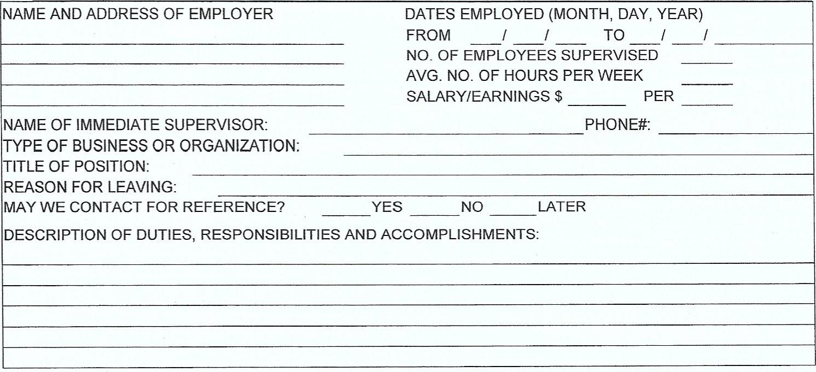

WORK EXPERIENCE (CONT'D)
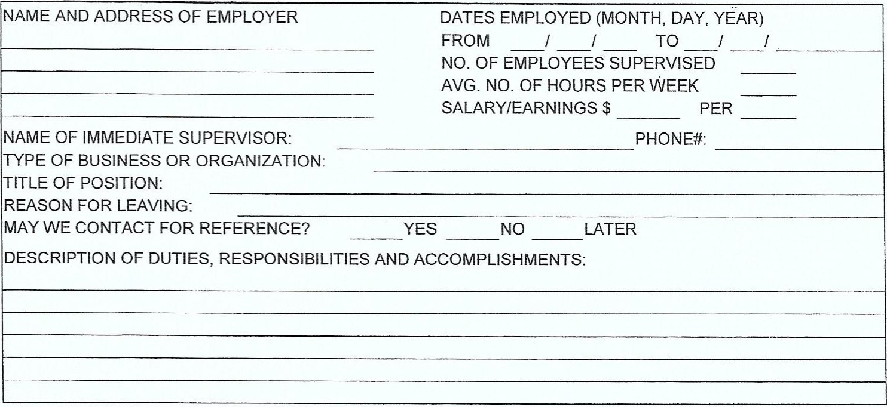
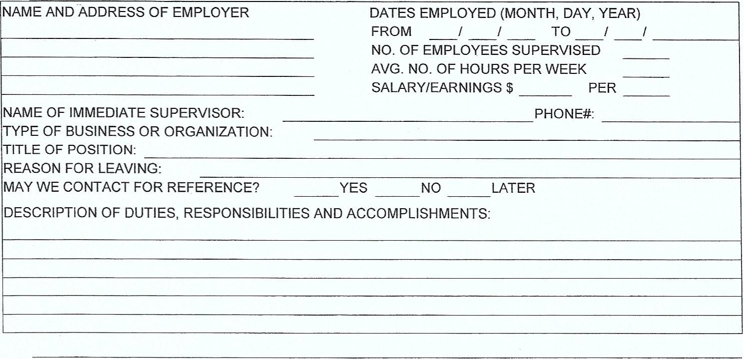

COMMENTS:

PART 7 |  |  |  |  |  | REFERENCES
LIST NAME AND TELEPHONE NUMBER OF THREE PEOPLE WHO ARE NOT RELATED TO YOU AND ARE NOT PREVIOUS SUPERVISORS. AT LEAST ONE SHOULD KNOW YOU WELL ON A PERSONAL BASIS.
NAME TELEPHONE YEARS KNOWN
 |  | PART 8 |  |  |  |  | BACKGROUND INFORMATION
 |  |  | HAVE YOU EVER BEEN CONVICTED OF A FELONY? YES NO (If yes please explain)
IF YES, HAVE YOU RECEIVED A PARDON OR A RESTORATION OF CIVIL RIGHTS?
(IF YES, PLEASE PROVIDE DOCUMENTATION. YES NO
DO ANY OF YOUR RELATIVES CURRENTLY WORK FOR THE BLACKFEET TRIBE? ____ YES _____ NO
If YES, provide details below. If you need more space, attach an additional page. "Relative" is defined as any person related to the employee by blood, marriage or adoption in the following degrees: husband, wife, father, mother, child, sister, brother, grandparent, grandchild, mother-in-law, father-in-law, sister-in- law, brother-in-law, son-in-law, daughter-in-law, niece, nephew, aunt, uncle, first cousin or other legal dependent, regardless of residence, and any other family member who resides in the same household. Personnel Policies and Procedures, 13-2-1)
 |  |  |  | NAME |  |  |  |  |  | RELATIONSHIP |  | PROGRAM
 |  |  |  |  | PART 9 |  |  | SIGNATURE, CERTIFICATION AND RELEASE OF INFORMATION
YOU MUST SIGN THIS APPLICATION. READ THE FOLLOWING CAREFULLY BEFORE SIGNING
It is understood and agreed upon that any misrepresentation by me in this application will be sufficient cause for cancellation of this application and/or separation from the employer's service if I have been employed.
I give the employer the right to investigate all references and to secure additional information, if job related. I hereby, release from liability the employer and its representatives for seeking such information and all other persons, corporations or organizations for furnishing such information.
All applicants tentatively selected for this position will be required to submit to a urinalysis and/or hair analysis testing to screen for illegal drug use prior to appointment.
I CERTIFY THAT, TO THE BEST OF MY KNOWLEDGE AND BELIEF, ALL OF MY STATEMENTS ARE TRUE, CORRECT, COMPLETE, AND MADE IN GOOD FAITH.
SIGNATURE DATE
____________________________________________________________ ________________________

Why are you the best candidate for this position?

________________________________________________________________________________________________

________________________________________________________________________________________________

________________________________________________________________________________________________

_______________________________________________________________________________________________

_______________________________________________________________________________________________

_______________________________________________________________________________________________

_______________________________________________________________________________________________

Blackfeet Personnel Department
Background Check Authorization
P. O. BOX 1790 Browning, MT 59417
(406) 338-7307 0 FAX (406) 338-7313
PROGRAM/DEPARTMENT: _________________________ POSITION: ________________________

NAME: _______________________________________________________________________________
(FIRST) (MIDDLE) (MAIDEN) (LAST)
ALIAS/ OTHER NAMES USED:

DATE OF BIRTH:
(MONTH) (DAY) (YEAR)
PHONE NUMBER ( )
(
SOCIAL SECURITY NUMBER: __________________________________________________

LAST PLACE OF EMPLOYMENT: ________________________________________________

SUPERVISOR'S NAME/ PHONE: __________________________________________________

As part of the initial and subsequent application process, I hereby authorize any Tribal] State/Federal Law
Enforcement Agency to release any records they have regarding my background including a criminal history record check to the Blackfeet Personnel Department Browning, Montana. I understand that any information obtained from the background checks will be used by the Blackfeet Personnel Department to evaluate my application for employment/ subsequent annual application update for employment. I understand that I may be terminated from my position if the results of the investigation are contrary to the policies of the Blackfeet Tribe.
EMPLOYEE'S SIGNATURE DATE
__________________________________________________ ______________________
PARENTS SIGNATURE (If above individual is under 18 yrs. of age) DATE

***********************************************************************************************
CERTIFIED FOR HIRE/ REHIRE?YESNO
BY: _____________________________________________

DATE BACKGROUND CHECK WAS COMPLETED: _______________________________________

COMMENTS: __________________________________________________________________________

______________________________________________________________________________________
_______________________________________________________________________________________

